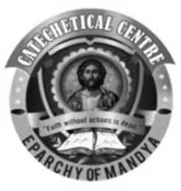
COMMISSION FOR BIBLE AND CATECHETICS
EPARCHY OF MANDYA
Photo
Note: You can send a photo by email as an attachment with the application form

SUNDAY CATECHISM
NEW / LATERAL ADMISSION APPLICATION FORM 2022-23
(PLEASE FILL IN BLOCK LETTERS)

HOLY FAMILY FORANE CHURCH, HONGASANDRA

http://www.holyfamilyforanechurch.com/
CLASS TO WHICH ADMISSION IS SOUGHT
STUDENT’S NAME
GENDER (MALE / FEMALE)
DATE OF BIRTH (dd-mm-yyyy)
BAPTISMAL NAME
DATE OF BAPTISM (dd-mm-yyyy)
PARISH AT WHICH BAPTISM RECEIVED
DATE OF FIRST HOLY COMMUNION
DATE OF CONFIRMATION
FATHER’S NAME
MOTHER’S NAME
FATHER’S MOBILE NO. & EMAIL ID
MOTHER’S MOBILE NO. & EMAIL ID
PREFERRED WHATSAPP NUMBER
PARISH FAMILY BOOK NO
PARISH WARD NAME
RESIDENTIAL ADDRESS &
LANDLINE NO. (IF AVAILABLE)
ACADEMIC SCHOOL NAME
ACADEMIC CLASS

(FOR LATERAL ADMISSION ONLY. PLEASE ATTACH ORIGINAL TC)
CLASS STUDENT LAST ATTENDED
TRANSFER CERTIFICATE (TC) NUMBER
TRANSFER CERTIFICATE ISSUE DATE
NAME OF SUNDAY SCHOOL (PARISH) THE STUDENT LAST ATTENDED

Submit the completed application form in the catechism office on Sundays between 9:30 AM and 12:00 PM.
For enquiries, please contact 8550054443

